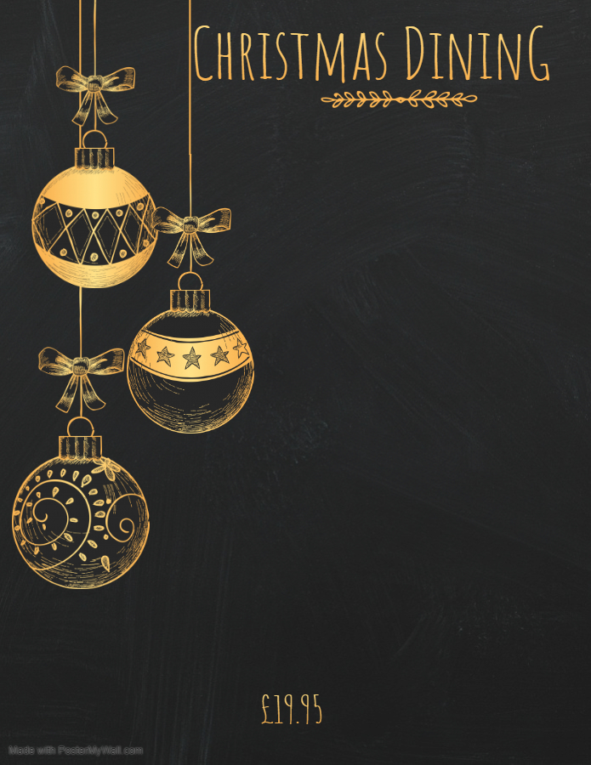

Scotch Broth
(served with roll & butter)

Crayfish, Prawn & Avocado Cocktail
(served with brown bread)

Chilled Melon & Raspberries
(marinated in crème de menthe)



Traditional Roast Turkey
(with all the trimmings)

Oven Baked Salmon Fillet
(with a Champagne & Dill Sauce)

Cheesy Celeriac, Leek & Potato Gratin

All above served with roast potatoes, boiled potatoes and seasonal vegetables.



Christmas Pudding
(with Brandy Sauce)

White Chocolate and Baileys Cheesecake
(with fresh cream)

Cheese & Biscuits

