1911
Bar & Restaurant

CHILDRENS MENU

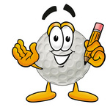

1911
Bar & Restaurant

CHILDRENS MENU

CHICKEN FILLETS

CHEESE & TOMATO PIZZA

PORK SAUSAGES

MACARONI CHEESE

All served with Chips and Beans or Peas

All meals £5 incl. Drink & Ice-cream

Under 5’s eat free from children’s menu

CHICKEN FILLETS

CHEESE & TOMATO PIZZA

PORK SAUSAGES

MACARONI CHEESE

All served with Chips and Beans or Peas

All meals £5 incl. Drink & Ice-cream

Under 5’s eat free from children’s menu

