SWEETS
HOMEMADE STICKY TOFFEE PUDDING
HOMEMADE CHEESECAKE OF THE DAY
HOMEMADE WARM CHOCOALTE BROWNIE
all served with cream or ice-cream
All |  | £3.95
Various Scones & Traybakes
HOT DRINKS
Latte | £1.90
Americano | £1.90
Cappuccino | £1.90
Hot Chocolate | £1.90
Instant Coffee | £1.50
Selection of Teas | £1.50

Please ask a member of staff for our gluten free menu

1911
Bar & Restaurant

MENU

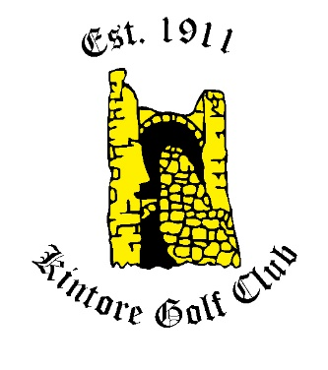

Tel: 01467 632631
Email: bar@kintoregolfclub.net
Kintore Golf Club

BREAKFAST
Filled Rolls -Bacon, Sausage, Egg, Black Pudding, Lorne Sausage, Haggis
1 Item |  | £3.00
2 Items |  | £3.50
3 items |  | £4.00
The Full Monty |  | £5.00
LIGHT BITES
NACHOS
Topped with Cheese, Salsa & Sour
Cream |  | £4.00
add Chilli |  | £1.00
WRAPS
Cold Fillings |  | £5.00
Tuna Mayo Salad (v), BLT, Chicken Mayo Salad
Hot Fillings |  | £5.00
BBQ Chicken with Cheese
Spicy Southern Fried Chicken with
Cheese
TOASTIES & SANDWICHES
Chicken Mayo, Tuna Mayo, Cheese & Onion(v), Cheese & Ham, Cheese & Pickle, Ham & Tomato, Egg Mayo(v), Cheese & Tomato (v)
 |  | £4.00
BAKED POTATOES
Cheese (v), Cheese & Beans (v), Cheese & Onion (v), Tuna Mayo, Chicken Mayo, Chilli Beef and Cheese
 |  | £5.00
All of the above served with dressed salad garnish, coleslaw & tortilla chips.
SOUPS
Cullen Skink | £5.00
Homemade Soup of The Day | £3.95
MAIN MEALS
STEAK & ALE PIE
Served with vegetables and chips
CHICKEN FILLETS
Served with chips salad and coleslaw
BREADED SCAMPI
Served with chips and peas
MACARONI CHEESE
Served with chips or garlic bread
STEAK BURGER OR CHICKEN BURGER
Served in a toasted bun with chips, salad and coleslaw
Extra Toppings: Cheese, Bacon or Chilli
VEGETARIAN OPTION AVAILABLE
FISH & CHIPS
Fresh Peterhead Haddock, breaded or battered served with garden peas and chips.
All mains | £7.95
SALADS
Tuna Mayonnaise, Ham or Cheese
mixed salad leaves, diced peppers, red onion, cucumber, tomato and coleslaw.
Chicken Caesar Salad
mixed leaves, croutons, sliced chicken, Caesar dressing, parmesan.
All Salads | £7.95

